INSERT VALUES:
CREATE DATABASE CollegeDB;
USE CollegeDB;
CREATE TABLE Students (
StudentID INT PRIMARY KEY,
Name VARCHAR(50) NOT NULL,
Email VARCHAR(100) UNIQUE,
Age INT,
City VARCHAR(50)
);
DESC Students;
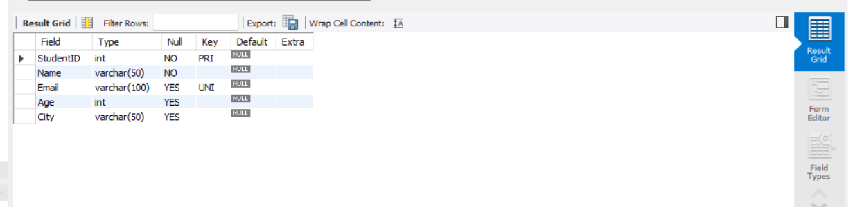
INSERT INTO Students (StudentID, Name, Email,Age, City) VALUES
(1, 'Akash', 'akash@gmail.com', 18,'Chennai'),
(2, 'Aathi', 'Aathi@gmail.com', 20, 'Delhi'),
(3, 'Karthess', 'Karthess@gmail.com', 21, 'Mumbai');
SELECT * FROM Students;
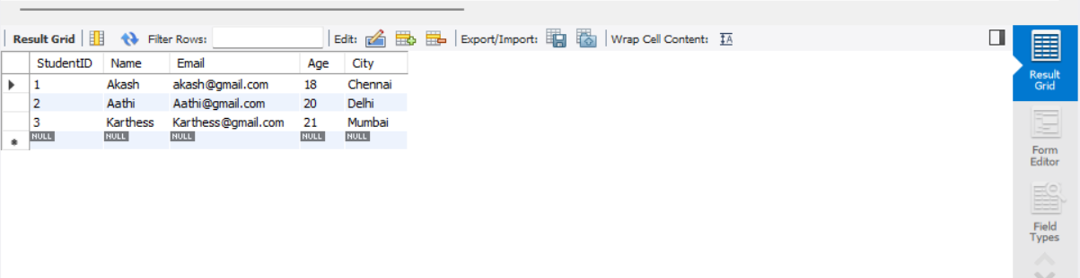

VIEW:
USE CollegeDB;
CREATE VIEW StudentsView AS
SELECT Name,City From Students;
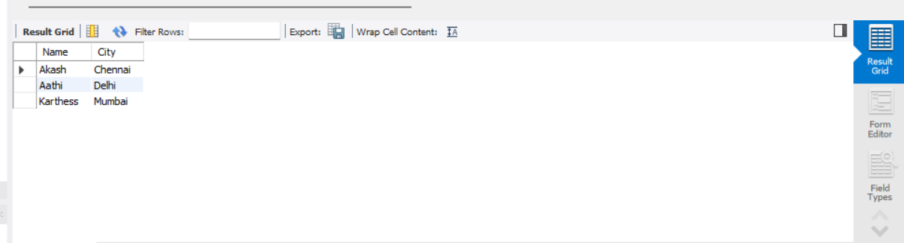
SELECT * FROM Students View;
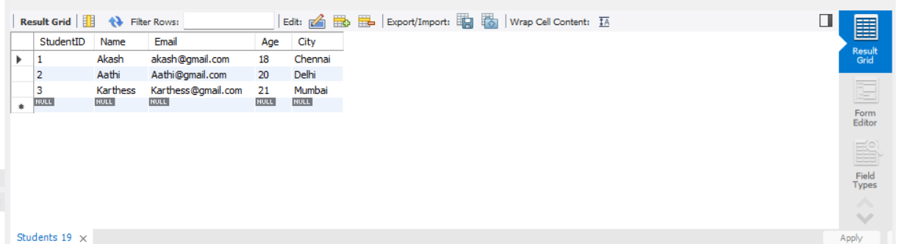
CREATE OR REPLACE VIEW Studentview AS
SELECT Name,Age From Students;
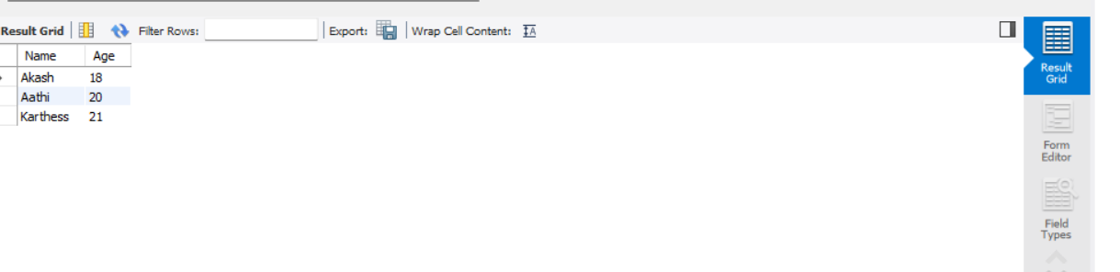
SELECT * FROM Students View;
DROP VIEW StudentsView;

